Experiment 8: Sine/Cosine Wave Generation using DDS Compiler IP
Objectives
- To design and simulate a Direct Digital Synthesizer (DDS) using the DDS Compiler IP core in Xilinx Vivado.
- To generate a sine wave signal with a frequency of 5 MHz using the DDS Compiler IP.
- To generate a cosine wave signal with a frequency of 10 MHz using the DDS Compiler IP.
- To analyze and verify the generated waveforms based on their frequency, amplitude and phase characteristics.
Required tools
Xilinx Vivado Design Suite / Vivado Simulator
Method:
A. Generation of 5 MHz Sine Wave: Configure the DDS Compiler IP core in Xilinx Vivado for sine-wave generation. Set the required system clock frequency and configure the phase increment/frequency control word to generate a 5 MHz output. Create the required RTL wrapper and simulate the design using Vivado Simulator. Observe the output waveform and measure its frequency from the simulation results. Compare the simulated frequency with the specified frequency of 5 MHz and calculate the percentage deviation.
B. Generation of 10 MHz Cosine Wave: Configure the DDS Compiler IP core for cosine-wave generation. Set the required system clock frequency and configure the DDS parameters to generate a 10 MHz output. Create the required RTL wrapper and simulate the design using Vivado Simulator. Observe the cosine waveform and measure its frequency from the simulation results. Compare the simulated frequency with the specified frequency of 10 MHz and calculate the percentage deviation.
C. Waveform Analysis: Analyze the simulated sine and cosine waveforms in terms of frequency, amplitude, periodicity and phase relationship. Verify that the generated output frequencies correspond to the specified 5 MHz and 10 MHz values with less than 5% deviation.
FORMULA TO BE USED:

fout​=(Phase Increment×fclk​​) / 2^(Phase width)
For Sine wave with 5 MHz
$$f_{out}=\frac{13×100 \text{MHz}}{256}≈5.08 \text{MHz}$$

For Cosine wave with 10 MHz
$$f_{out}=\frac{13×100 \text{MHz}}{256}≈5.08 \text{MHz}$$
Percentage deviation:
$$\% Deviation=\frac{\left|f_{simulated}-f_{expected}\right|}{f_{expected}}×100$$
Observation table
Item | Parameter checked | Target / Expected Frequency | Simulated / Measured Frequency | Deviation (%)
1 | Sine Wave Output (m_axis_data_tdata[15:0]) | 5.00 MHz | 5.078 MHz | < 1.6%
2 | Cosine Wave Output (m_axis_data_tdata[31:16]) | 10.00 MHz | 10.156 MHz | < 1.6%
3 | Output Amplitude Dynamic Range | 16-bit Signed (-32768 to +32767) | 16-bit Signed Waveform | 0% Clipping
4 | Phase Accumulator Stability | Continuous Phase Rollover | Smooth Sinusoidal Output | Pass
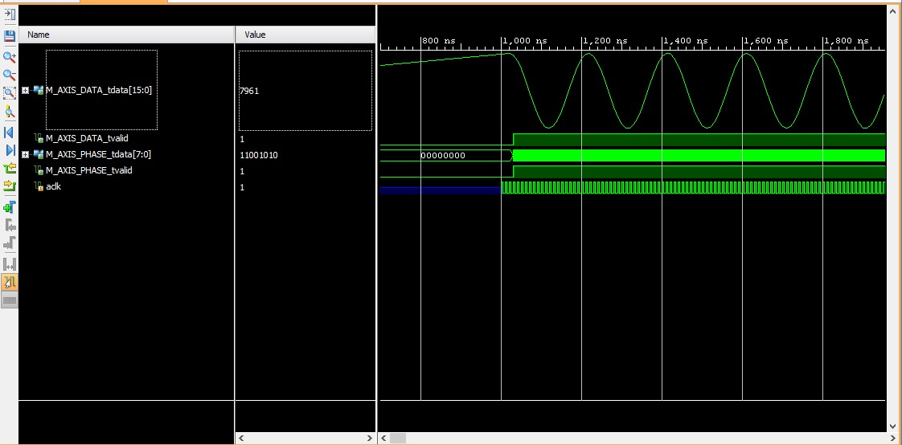
Figure 1: Generated cosine wave
Conclusion
The Direct Digital Synthesizer (DDS) waveform generation system was successfully configured and simulated using the DDS Compiler IP core in Xilinx Vivado. Simulation results in Vivado Simulator (XSIM) confirm that a 5 MHz sine wave (Phase Increment = 13, fout ≈ 5.078 MHz) and a 10 MHz cosine wave (Phase Increment = 26, fout ≈ 10.156 MHz) were synthesized from a 100 MHz base clock with less than 5% frequency deviation, validating digital waveform synthesis accuracy.

